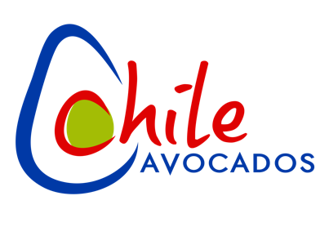

Chilean Avocado Importers Association 2025/26 Marketing Plan

Based on 22.5 million pounds

July 1, 2025 to June 30, 2026

2.02 Social Media $ 100,000

2.03 Trade Marketing $ 500,000

2.04 Professional Expenses $ 120,000

2.05 Meetings & Sponsorships $ 5,000

2.06 Administrative Expenses $ 24,673

TOTAL $ 749,673

**CAIA PURPOSE**

To conduct market development activities and communication programs to increase the consumption of Avocados from Chile in the United States.

**CAIA STRATEGIC PRIORITY**

Concentrate efforts on clearly differentiating Avocados from Chile by building strong consumer awareness and driving targeted retail demand in key markets.

1. Prioritize branded messaging that highlights the unique qualities and premium positioning of Chilean Avocados.
2. Define and communicate the competitive advantages of Chilean Avocados, crafting a compelling brand story that resonates with both consumers and trade partners.
3. Allocate resources toward high-impact retail partnerships within core geographic markets.
4. Center marketing and promotional activities within the prime window of opportunity: **September to December 2025**.

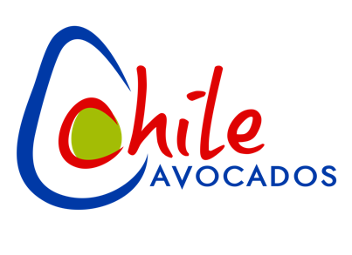

**2025/2026 Strategic Marketing Plan Key Elements**

***Social Media: $80,000***

Develop a consistent stream of engaging content and seasonal messaging—paired with compelling images and short-form videos—to raise awareness of Chilean Avocados and drive traffic to the CAIA website and key social media platforms of Facebook and Instagram.

**Social Media Objectives**

* Increase brand awareness of CAIA and promote Chilean avocado consumption among target audiences.
* Leverage Instagram and Facebook to showcase the unique attributes of Chilean avocados, including their rich flavor, nutritional value, and the expertise of the Chilean growers.
* Strengthen CAIA’s position as a leader in the avocado industry by sharing innovative recipes, health insights, and stories that reflect our commitment to quality and excellence.
* Cultivate a vibrant, engaged online community of avocado enthusiasts—educating and inspiring followers to make avocados a key part of their daily lifestyle.

**Proposed Tactics**

* Encourage and share user-generated content that showcases creative avocado uses, meals, and moments, helping to foster community engagement and authenticity.
* Collaborate with food, wellness, and lifestyle influencers to amplify reach and drive credibility among target demographics.
* Run seasonal giveaways or contests to boost follower engagement and increase visibility of Chilean Avocados.
* Develop themed content series (e.g., “Avocado Tip Tuesday” or “Farm to Table Fridays”) to build consistent engagement and reinforce key messaging.

* Share behind-the-scenes content from Chilean avocado orchards to highlight quality, sustainability, and the human stories behind the product.
* Use targeted social media advertising to reach new audiences and retarget website visitors with relevant content.
* Create short, engaging recipe videos and reels that are optimized for each platform and reflect seasonal trends.
* Leverage interactive content such as polls, quizzes, and Q&A sessions to engage followers and encourage participation

***Trade Marketing: $500,000***

We will implement targeted programs to inform and educate retailers about the availability and exceptional quality of Chilean Avocados. Additionally, we will launch retail-focused initiatives designed to increase in-store visibility for Avocados from Chile and drive consumer demand in core markets where they are consistently available.

**Chilean Avocado Messaging Strategy**

**Trade Communication**

* Maintain ongoing engagement with current and prospective retail partners for Avocados from Chile
* Promote Chilean Avocados through trade publications as needed

**Retail Promotions**

* Partner with key retailers to execute promotional campaigns throughout the season
* Develop and distribute customized marketing materials to help boost visibility and sales of Avocados from Chile

***Professional Fees/Expenses: $120,000***

* Fees and expenses for Managing Director; AMS-USDA oversight fees

***Meetings & Sponsorships: $5,000***

* Expenses for CAIA sponsorship of BOLD Participant

***Administrative Expenses: $24,673***

**TOTAL Marketing Expenses: $725,000**

**TOTAL Administrative Expenses: $24,673**

**TOTAL COMBINED EXPENSES: $749,673**